Social Media

* What day should we post content ?
  + 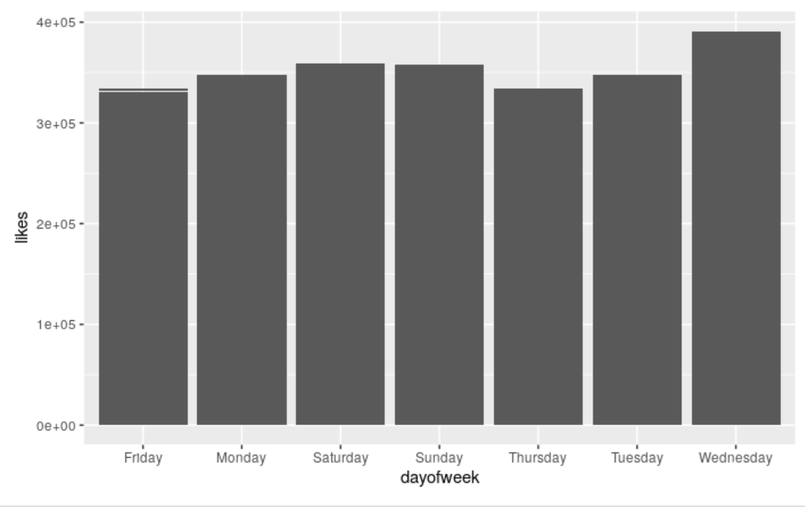
* What is trending
  + 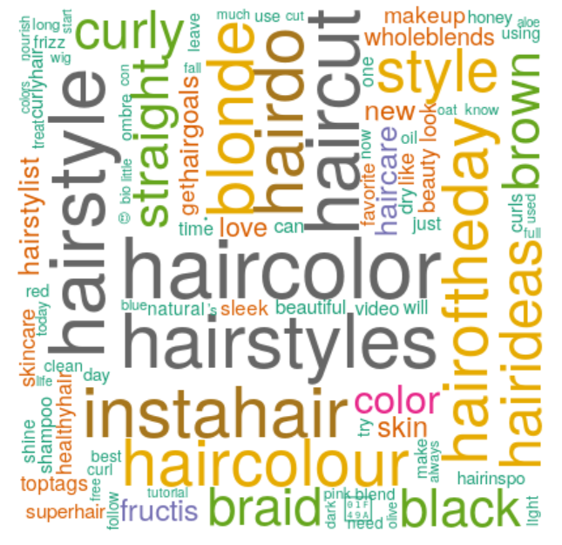
* Colors
  + 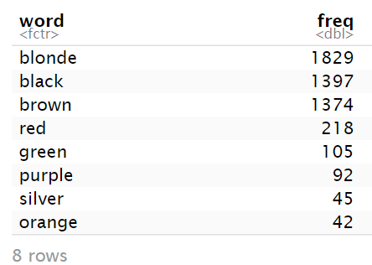
* Shades
  + 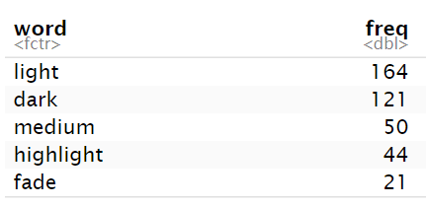
* Overall emotions
  + 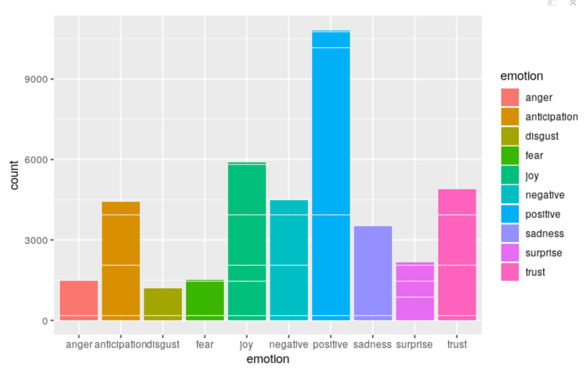
* Pricing

|  |  |
| --- | --- |
|  |  |

* + 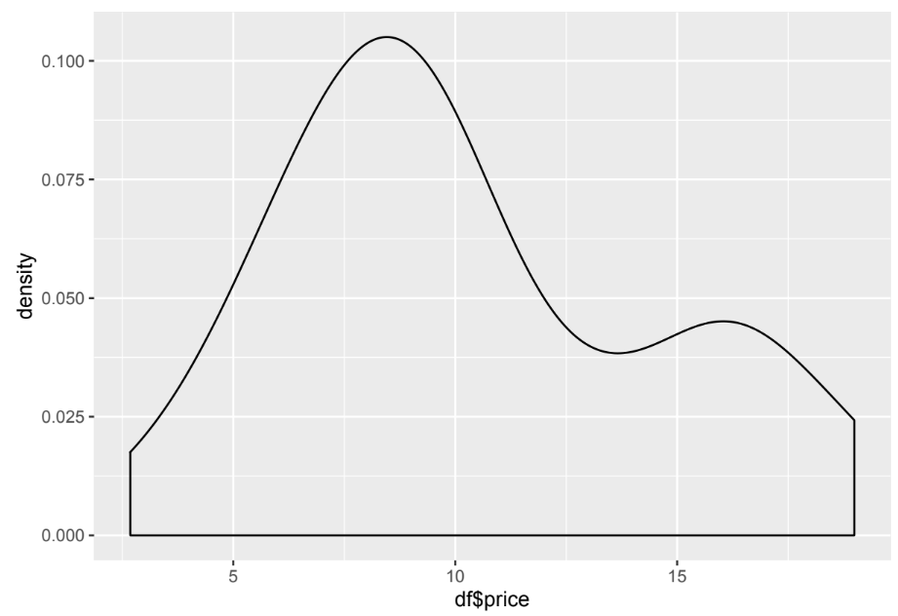
* Amazon Rank increases with price – people are not viewing high price products
  + 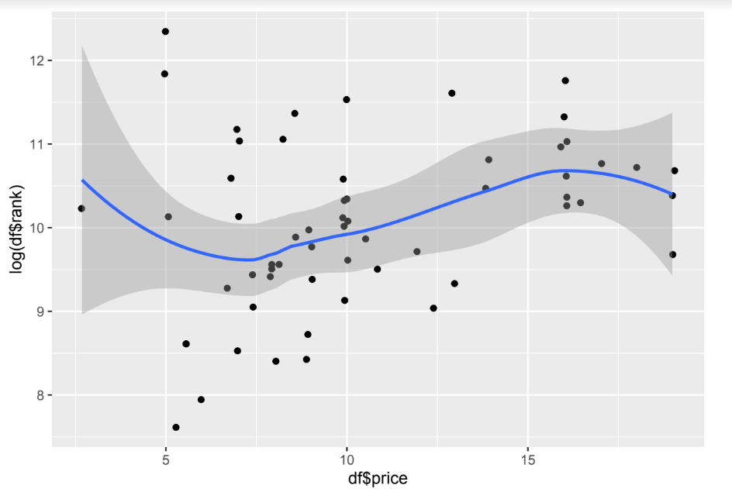
* Amazon Rank decreases with stars and total number of ratings

|  |  |
| --- | --- |
|  |  |

* Amazon Color analysis
  + 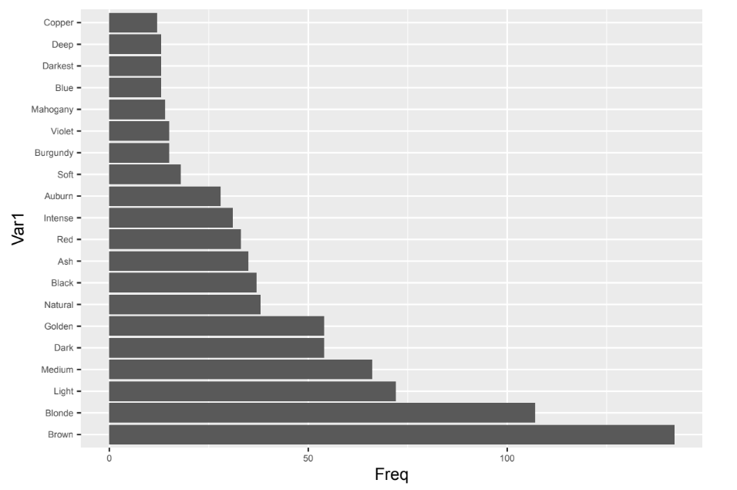
* Competition
  + 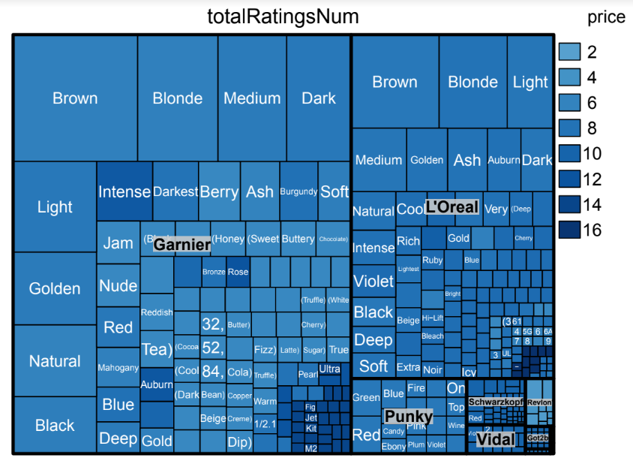

|  |
| --- |
| Fewer people are going for these but still liking them |